Project #3

False Sharing

By Michael Rose

Due: May 3rd

Written for: CS475 Spring 2016

Oregon State University

Table of Contents

What I did 3

What System I Used 3

Results 3

Analysis 4

# What I did

I step up a script that sets the number of thread, for the fix 1, the script also adjusts the padding size from 0 to 16. I output each file into 2 different CSVs. I then wrote a Python script that uses pull it to plot the data. The script is included in the zip file. It outputs 3 images because sometimes the legend looks fine on the images and sometimes it doesn’t.

# What System I Used

I ran this on my local Linux box. It has an older model 4-core i5.

# Results

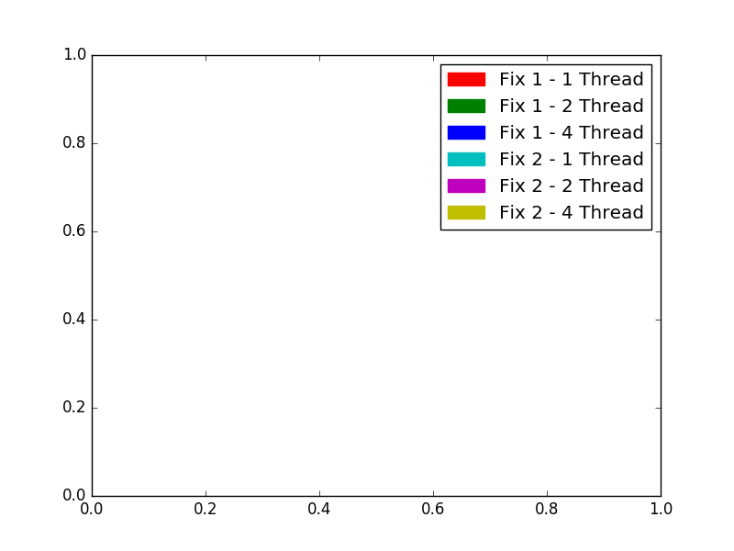

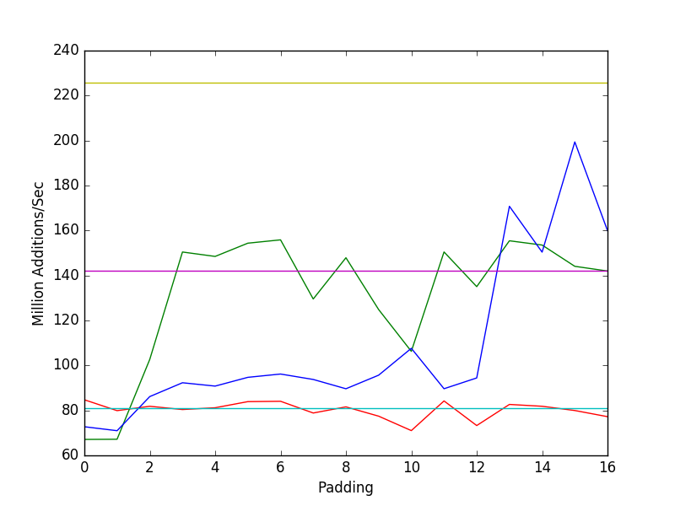

# Analysis

The private local variables (fix 2) gives performance that is about as optimal as padding gets. On the other hand, poor padding can greatly hurt performance. This is most obvious with the 4 thread lines, with padding less than 13, the performance is basically half the performance of using fix 2. Padding size 6, 13, 14 and 15 seem to be the best performance, though this does vary slightly with thread count.